FBDA Lab 11 Task B

Output of the first command
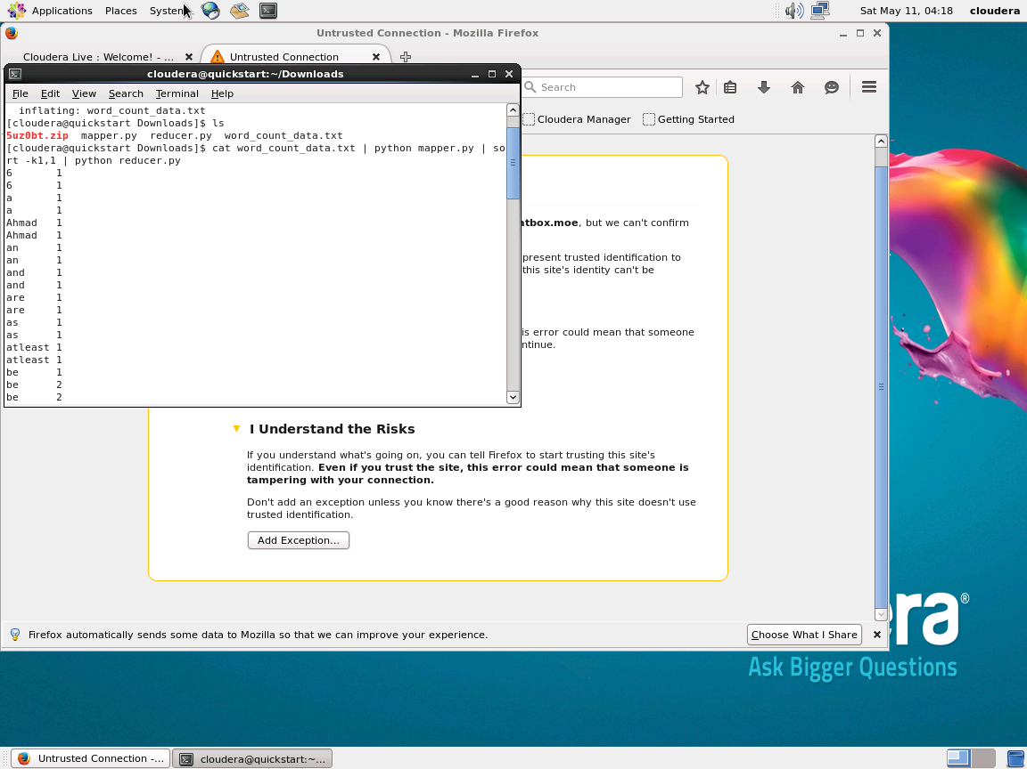

File Copied to hdfs
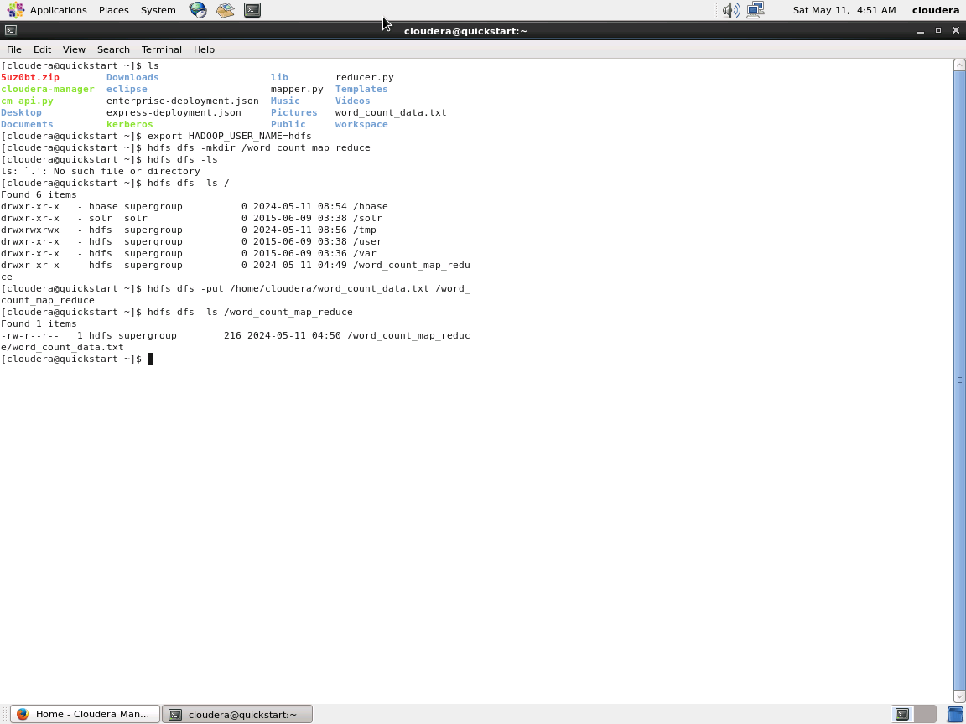

Important note, so far i tried 9 times mapreduce and it doesn’t finish
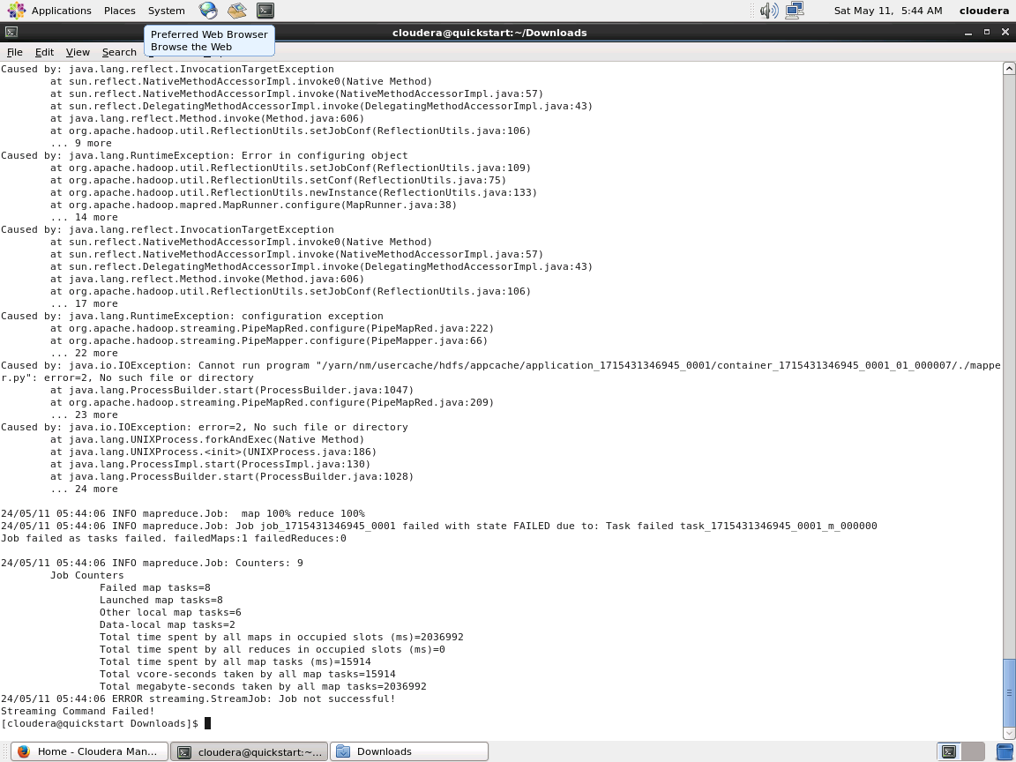
Using buitin mapper and reducer will work, due to the bug in mapper code that we saw
